Greylock Roofing Company Inc,
New England Region Alliance Members 2023 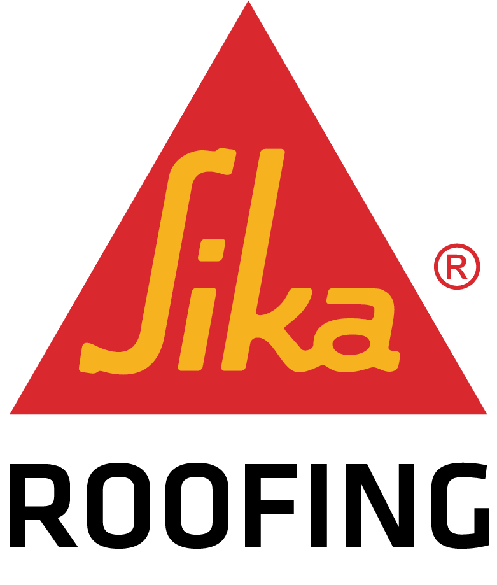
60 Jospin Road
Wilmington Ma 01887

Capeway Roofing Systems, Inc.
664 Sanford Road
PO Box 706
Westport MA 02790

Gilbert & Becker Company Inc.
16-24 Clapp Street
PO Box 255066
Dorchester MA 02125

JD Rivet & Company, Inc.
PO Box 51066
Indian Orchard Ma 01151

John F. Shea Company, Inc.
655 Bodwell Street
Avon MA 02322

Tri State Roofing Systems, Inc.
788 Sheridan Street
Chicopee MA 01020
Crocker Architectural Sheet Metal Co
129 Southbridge Road
North Oxford MA 01537

Jack Flynn & Sons, Inc.
86 East Bacon Street
Plainville Ma 02762

Kidd- Luukko Corporation
23 North Street
Worcester Ma 01605

Membrane Concepts
8 Rounseville Street
PO Box 51262
New Bedford MA 02745

MK Specialities, Inc.
(Cape Cod Copper)
26 Crooked Lane
Lakeville Ma 02347

Northern Roofing Contractors LLC
80 Cambridge Street Methuen Ma 01844
Phil’s Main Roofing Co., Inc
26 Fitch Street Norwalk CT 06855
Viking Roofing
10 Clinton Drive
Hollis NH 03049

Reliable Roofing & Sheet Metal
105 Irving Street
Framingham Ma 01702

C&M Roofing Co. LLC
195 So Main St
PO Box 307
South Windsor CT 06074

Progressive Roofing. Inc
261 River Street
Haverhill MA 01832

R&S Construction Services Inc.
P.O Box 121
Middlebury CT 06762

Applied Roofing Systems Inc.
26 Mill Street
PO Box 1248
Webster MA 01570

A&M Roofing & Sheet Metal Co. 123 Tewksbury Street Andover, MA 01810 978-475-4500

Barrett Inc.
106 Mill Plain Road
Danbury, CT 06811
203-744-2780
Douglas J. Wooliver & Sons Old Cheshire Road Lanesboro, MA 01237
413-442-0192
Eagle Rivet Roof Service Corp.
15 Britton Drive Bloomfield, CT 06002
860-953-1231
Ernest Peterson Inc.
1830 Broad Street
Hartford, CT 06114
860-522-4271
Feeley, McAnespie, Inc
PO BOX 280
Chelmsford, MA 01824
978-441-2300
Gibson Roofs, Inc.
369 Winter Street
Hanover, MA 02339
781-826-6344

Hahnel Brothers Company PO BOX 1160
Lewiston, ME 04043
207-784-6477
K1 Roofing LLC
90 Corporate Park Drive, Suite 146 Pembroke, MA 02359 781-422-4759
M.D.M. Inc.
51 Sawmill Road Dudley, MA 01571 508-949-1616
M.J. Ambrose Enterprises Inc
24 River Street Dedham, MA 02026 781-751-9000
Marshall Roofing & Sheet Metal Co Inc
PO Box 3279 Peabody, MA 01960 978-548-6000
Merrick Engineering Co.
PO BOX 414 Brockton, MA 02301 508-583-0940
Morris Roofing Solutions, LLC
62 Sawyer Drive
Coventry, RI 02816 401-722-2229
Nations Roof of New England LLC
420 Frontage Road West Haven, CT 06516
203-335-8949

Northstar Construction Services Corp
200 Mt Laurel Circle Shirley, MA 01464 978-425-0001
Paul J Cazeault & Sons, Inc. 1031 Main Street
Osterville, MA 02655
508-428-1177
Prime Roofing Corp
30 Tricnit Road #13 New Ipswich, NH 603-878-3550
R. D. Scinto, Inc. 1 Corporate Drive Shelton, CT
06484 203-929-6300
Skyline Roofing Inc
861 Page Street Manchester, NH 03109 603-669-0131
SRC Roofing, Inc.
166 Brook Road Quincy, MA 02169 617-479-2060
Stella Construction
21 Westdale Ave Wilmington, MA 01887 781-999-1572
Tech Roofing Service, Inc.
896 Sheridan Street Springfield, MA 01020 413-737-5546
Tecta America of New England
2 Sterling Road North Billerica, MA 01862
978-436-9990
Allied Roofing & Sheet Metal Co Inc.
PO BOX 280744
East Hartford, CT 06128
860-289-4374
AMK Construction, Inc.
9 Otis Road Unit 5
Beverly, MA 01915
978-927-7765

Top Tech Roofers LLC
612 Plain Street Suite 6 Marshfield, MA 02050
781-837-9398

United Roofing & Sheet Metal Inc.
500 Federal Road
Ridgefield, CT 06804
860-488-2970

US Roofing
58 Pulaski St Rear
Peabody, MA 01961
978-700-0350
W.S Aiken, Inc.
224 Crescent Avenue Chelsea, MA 02150
617-889-0665
New England Region General Members 2023
Larochelle Construction Inc.
23 College St Suite 8
S.Hadley Ma 01075
Almar LLC
106 Adams St
Medfield, MA 02052
508-813-2275
Applied Roofing Systems Inc 26 Mill Street
Webster, MA 01570
508-943-9973
Aqua Barriers, Inc.
50 Rockwood Rd
Norfolk, MA 02056
800-660-1859
Autumn Construction
15 Winer Street Suite #9 Edgartown, MA 02539
508-509-1153
B.C. Roof Service
257 Ruthellen Road Bellingham, MA 02019
508-966-1370

Beantown Restorations, LLC 16 Spellman Rd
Westwood, MA 02090
617-680-0742

C & M Roofing Co., LLC
195 So Main St
South Windsor, CT 06074 860-758-7708
CDA Roofing & Siding Contractors
1775 Main Street Agawam, MA 01001
413-786-4081
Chapman Waterproofing Co. PO Box 255300 Boston, MA 02125 617-288-3000
Commercial Water Integration, Inc
418 Pinehill Road Westport, MA 02790 508-958-3964
Constitution Contracting Inc. 181 Stedman Street Unit 4 Lowell, MA 01851
978-770-1821
Crocker Architectural Sheet Metal C
129 Southbridge Road North Oxford, MA 01537
508-987-9900
D.P. Carney Construction, Inc.
34 Horseshoe Circle Ware, MA 01082 413-967-7124
Diversified Roofing Systems, Inc.
230 Coffin Avenue
New Bedford, MA 02746 508-999-6677
Doxsee Roofing LLC
PO Box 938 Bennington, VT 05201 802-447-0143
Eagle Cornice Company, Inc. 89 Pettaconsett Avenue Cranston, RI 02920
401-781-5978
Evergreen Roofing LLC
61 So. Oak Circle, Unit 3 Colchester, VT 05446
802-865-2264
F.J. Dahill Co., Inc.
PO Box 9578 New Haven, CT 06535 203-469-6454
Fred Falcone Roofing & Property Service
359 Center Street Pembroke, MA 02359 781-293-3126
Furey Roofing & Construction Co.
85 Cypress Street Warwick, RI 02888
401-461-2100
G&E Roofing Co. Inc.
669 Riverside Drive Augusta, ME 04330 207-622-9503
George A Barnard Company 100 North Street Worcester, MA 01605 508-755-5104
Hollstein Roofing Company Inc.
14 Hanover St Suite 11 Hanover, MA 02339
617-212-8049
Industrial Roofing Corp.
9 Ferry Road Lewiston, ME 04241 207-784-4551
Interstate Roofing and Sheet Metal
569 Atherton Street Milton, MA 02186 866-251-8317
J. Bennette Co., Inc.
27 University Avenue Pembroke, MA 02359
508-294-0855
Jack Flynn & Sons, Inc.
86 East Bacon Street Plainville, MA 02762
508-695-2272

Kidd-Luukko Corporation
23 North Street Worcester, MA 01605 508-799-9500
M. Duffany Builders, Inc.
200 Palmer Ave. Falmouth, MA 02540 508-540-3625
Macri Roofing, Inc.
36 Duffy Avenue Meriden, CT 06451 203-235-7510
Mastrangelo and Sons LLC
67 Smith Place Unit 14 Cambridge, MA 02138 617-484-3335
Max Sontz Roofing Services, Inc.
82 Sanderson Avenue Lynn, MA 01902 781-593-9300
McKenna Roofing & Construction Inc.
241 Armistice Blvd Pawtucket, RI 02861 401-374-7929
McNally Roofing Company
12 Rock Hill Road Boston, MA 02130 617-522-5353
Membrane Concepts
8 Rounseville Street North Easton, MA 02356
508-801-3206
MK Specialties, Inc.
26 Crooked Lane Lakeville, MA 02347 508-946-1999
North County Roofing, LLC 18 Normac Road Woburn, MA 01801 781-405-9001
Northeast industrial Roofing
510 Riverside Ave Medford, MA 02155 781-853-3536
Northern Roofing Contractors LLC
80 Cambridge Street Methuen, MA 01844 781-272-5661
Offshore Construction
280 Hartford Road Manchester, CT 73143 860-432-0260
P.O. Roofing LLC
3 Dolge Ct. Oxford, MA 01540 508-269-4128

Palmieri Roofing, Inc.
P.O. Box 567 Saint Johnsbury, VT 05819
802-748-9628
Phil's Main Roofing Co., Inc. 26 Fitch Street Norwalk, CT 06855 203-838-4545

Premier Building Associates, LLC
31 Acorn Road Branford, CT 06405 203-208-1378
Progressive Roofing, Inc.
261 River Street Haverhill, MA 01832 978-521-9100
R & S Construction Services Inc.
P.O. Box 121 Middlebury, CT 06762 203-758-8500
R&H Roofing, LLP
59 South Street Easthampton, MA 01027 413-527-9378
Reliable Roofing & Sheet Metal
105 Irving Street Framingham, MA 01702 508-628-5562
RGT Enterprises, Inc.
50 Industrial Way Hanover, MA 02339 781-878-7884

Roofing Concepts, Inc.
1500 South County Trail East Greenwich, RI 02818 401-885-5800
Rowland Roofing
421 Page Street Stoughton, MA 02072 617-562-5703
Tecta America New England LLC
332 Target Industrial Circle Bangor, ME 04401 978-436-9990
Twin Metals, Inc.
86 Bellerica Ave Unit 6 Billerica, MA 01862
978-663-2563
VAZ Construction, Inc.
93 Perry St New Bedford, MA 02745 774-328-9950
Vermont Roofing Co., Inc.
PO Box 237 Rutland, VT 05702 802-775-4386
Vermont Roofing Company Inc
1325 Harwood Hill Rd. Bennington, VT 05201 802-442-2899
Viking Roofing
10 Clinton Drive Hollis, NH 03049 603-883-6642
Wayne Roofing Systems, Inc. 65 E Belcher Road Foxboro, MA 02035 774-215-533

Cape Cod Builders Inc.
14 Bosuns Lane
Bourne Ma 02532
508-566-1510

