Sika thermoformed plastic formliners are able to accommodate form pressures up to a maximum 1,000 lb/ft² in all three of the rigid, plastic grades manufactured.
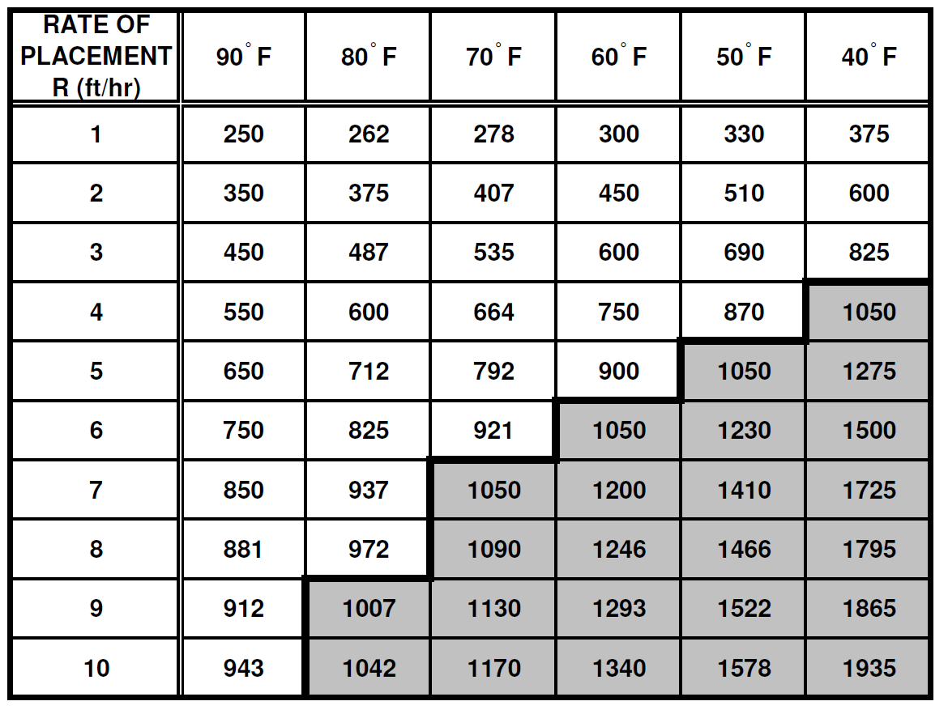
The maximum recommended rate of placement of Sika formliners is shown in the following table.

Based on ACI 347 - Guide to Formwork for Concrete, pressure formulas for concrete placement at 10 ft/hr or less. The table shown is based on the following assumptions:
ACI 347R Section 2.2.2.1 For concrete made with Type I cement, weighing 150 lb/ft³, containing no pozzolans or admixtures, having a slump of 4 inches or less, and normal internal vibration to a depth of 4 feet or less, formwork may be designed for lateral pressures as follows, where R = rate of placement, ft/hr; and T = temperature of concrete in the form (°F). For walls with a rate of placement less than 7 ft/hr (Eq. 2-2a: p = 150 + 9000 R / T ) and for walls with a rate of placement of 7 to 10 ft/hr (Eq. 2-3: p = 150 + 43,400/T + 2800 R / T), both with a maximum of 2,000 lb/ft², a minimum of 600 lb/ft², but in no case greater than 150h.
The table also assumes that the temperature of the concrete at the time of placement is roughly equal to the ambient air temperature. These values will be skewed slightly if placing concrete at very cold or very hot temperatures.
For More Information Contact
Sika - St. Louis Sales Office
3400 Tree Court Industrial Blvd.
63122, St. Louis, MO
United States
www.USA.Sika.com
Phone: 1-800-325-9504
Fax: 800-551-5145

Sika Corporation - US
201 Polito Avenue
Lyndhurst, NJ 07071
United States
Usa.Sika.com

Sika Corporation - US
201 Polito Avenue
Lyndhurst, NJ 07071
United States
Usa.Sika.com

