Sarnafil®
Green Roof –
Extensive
Loose-Laid System
Waterproofing
Specification

Conventional Assembly
DISCLAIMER

All information provided by Sika Corporation (“Sika”) concerning Sika products, including but not limited to, any recommendations and advice relating to the application and use of Sika products, is given in good faith based on Sika’s current experience and knowledge of its products when properly stored, handled and applied under normal conditions in accordance with Sika’s instructions. In practice, the differences in materials, substrates, storage and handling conditions, actual site conditions and other factors outside of Sika’s control are such that Sika assumes no liability for the provision of such information, advice, recommendations or instructions related to its products, nor shall any legal relationship be created by or arise from the provision of such information, advice, recommendations or instructions related to its products. The user of the Sika product(s) must test the product(s) for suitability for the intended application and purpose before proceeding with the full application of the product(s). Sika reserves the right to change the properties of its products without notice. All sales of Sika product(s) are subject to its current terms and conditions of sale which are available at usa.sarnafil.sika.com or by calling 800-451-2504.

Prior to each use of any Sika product, the user must always read and follow the warnings and instructions on the product’s most current Product Data Sheet, product label and Safety Data Sheet which are available online at usa.sarnafil.sika.com or by calling Sika's Technical Service Department at 800-451-2504. Nothing contained in any Sika materials relieves the user of the obligation to read and follow the warnings and instruction for each Sika product as set forth in the current Product Data Sheet, product label and Safety Data Sheet prior to product use.

Sika warrants this product for one year from date of installation to be free from manufacturing defects and to meet the technical properties on the current Product Data Sheet if used as directed within shelf life. User determines suitability of product for intended use and assumes all risks. Buyer’s sole remedy shall be limited to the purchase price or replacement of product exclusive of labor or cost of labor.

NO OTHER WARRANTIES EXPRESS OR IMPLIED SHALL APPLY INCLUDING ANY WARRANTY OF MERCHANTABILITY OR FITNESS FOR A PARTICULAR PURPOSE. SIKA SHALL NOT BE LIABLE UNDER ANY LEGAL THEORY FOR SPECIAL OR CONSEQUENTIAL DAMAGES. SIKA SHALL NOT BE RESPONSIBLE FOR THE USE OF THIS PRODUCT IN A MANNER TO INFRINGE ON ANY PATENT OR ANY OTHER INTELLECTUAL PROPERTY RIGHTS HELD BY OTHERS.

With respect to any guide specifications prepared and provided by Sika, such guide specifications are generic and nature and are provided as a general guide for informational purposes only to architects or roof designers/specifiers. Sika guide specifications are not intended to replace sound engineering and architectural practices and should not be relied upon for that purpose. Sika assumes no liability with respect to the provision of this guide specification, the preparation of the guide specifications, the design of the roofing or waterproofing system, the preparation and approval of the details and shop drawings, or for determining their suitability for a particular project or application. The architect, consultant and/or engineer or design professional for a particular project bears the sole responsibility for the design of the roofing or waterproofing system, for the preparation of the specifications, the preparation and approval of the details and shop drawings, and for determining their suitability for a particular project or application. Sika makes no warranty of any kind, either express or implied, as to the contents of these guide specifications. SIKA SHALL NOT BE RESPONSIBLE UNDER ANY LEGAL THEORY TO ANY THIRD PARTY FOR ANY DIRECT OR CONSEQUENTIAL DAMAGES OF ANY KIND ARISING FROM THE USE OF THESE GUIDE SPECIFICATIONS.
Introduction
Loose-Laid Sheet Waterproofing System For Extensive Green Roofs 2
System Description 2
System Components 2
Regional Offices 5

Part 1 – General Conditions
1.01 Description 1
1.02 Quality Assurance 1
1.03 Submittals 2
1.04 Product Delivery, Storage and Handling 2
1.05 Job Conditions 2
1.06 Sequencing of the Work 3
1.07 Bidding Requirements 4
1.08 Warranties 4

Part 2 - Products
2.01 Waterproofing Membrane 4
2.01 System Flashing Products and Accessories 7
2.02 Vapor Retarder 9
2.03 Insulation/Thermal Barrier/Cover Board 9
2.04 Vector Mapping Grid and Connections 10
2.05 Separation Layer 10
2.06 Drainage Composite 10
2.07 Precast Concrete Pavers and Pedestals 11
2.08 Related Materials 11

Part 3 – Execution
3.01 Examination 12
3.02 Substrate Preparation 12
3.03 Wood Nailer Installation 13
3.04 Thermal Barrier Installation 13
3.05 Vapor Retarder Installation 14
3.06 Insulation Installation 15
3.07 Cover Board Installation 15
3.08 Vector Mapping Grid and Connections Installation 15
3.09 Separation Layer Installation 15
3.10 Thermoplastic Waterproofing Membrane Installation 16
3.11 Hot-Air Welding of Lap Areas 16
3.12 Membrane Flashings 17
3.13 Sarnaclad Metal Flashings 17
3.14 Temporary Cut-Off 17
3.15 Water Testing of Drains and Electronic Leak Detection Testing 18
3.16 Installation of Drainage Composite 18
3.17 Precast Concrete Paver System 18
3.18 Monitoring the Vegetative Cover Installation 18
3.19 Details 18

INTRODUCTION TO
SIKA LOOSE-LAID SHEET WATERPROOFING SYSTEM
FOR EXTENSIVE GREEN ROOFS

System Description

The Sika Loose-Laid Sheet Waterproofing System (Conventional Assembly) is designed to protect structures from the effects of water infiltration leading to structural deterioration and interior water damage. The system configuration includes insulation below the waterproofing membrane making it ideal for extensive green roofs (6 inches (152 mm) or less of growth media) installed over steel deck, but can be used over almost any structural deck. The insulation can be tapered to provide positive slope to drain.

System Components

ASSEMBLY 1

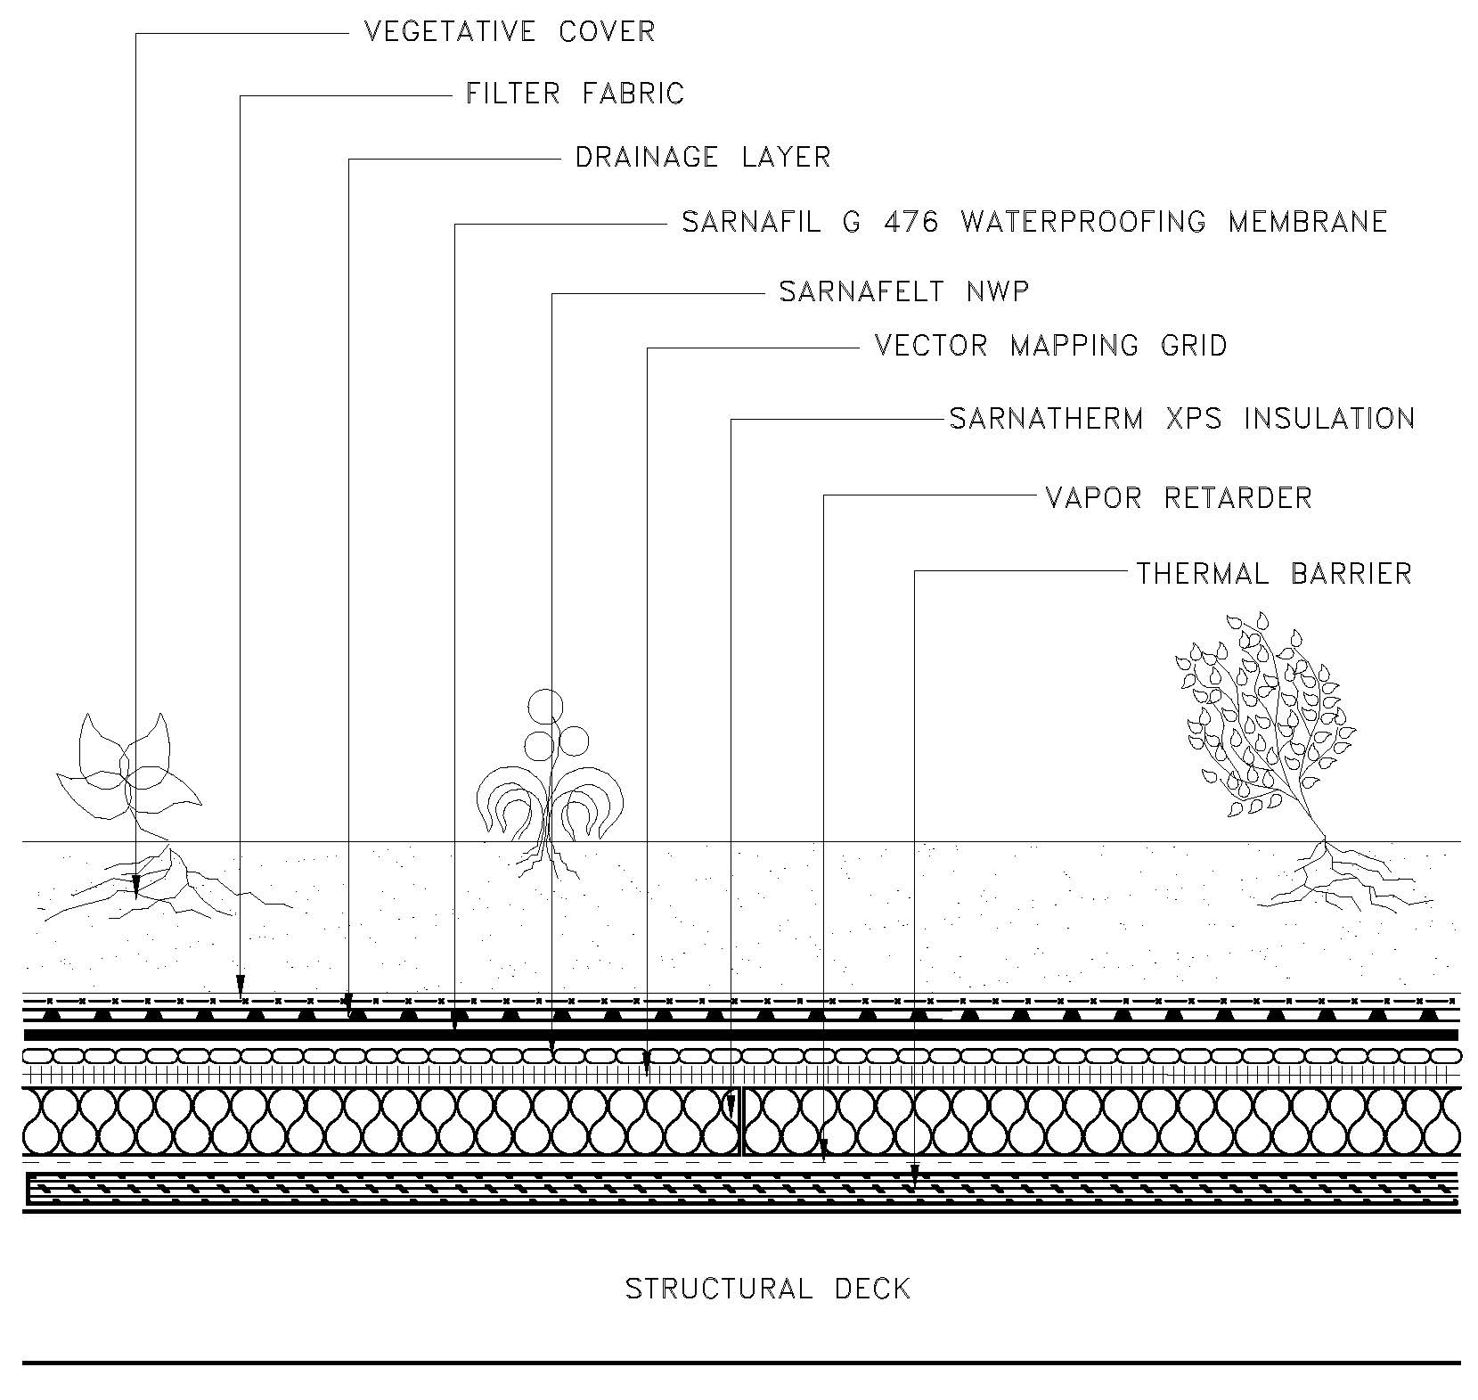

The Loose-Laid System Assembly 1 design includes the following:

- Thermal Barrier (if required).
- Vapor Retarder (if specified).
- Sarnatherm XPS Insulation.
- Vector Mapping Grid (VMG™) for Electronic Leak Detection Testing.
- Sarnafelt NWP Separation Layer.
- Sarnafil G476 Waterproofing Membrane.
- Drainage Layer.
- Filter Fabric (optional).

ASSEMBLY 2

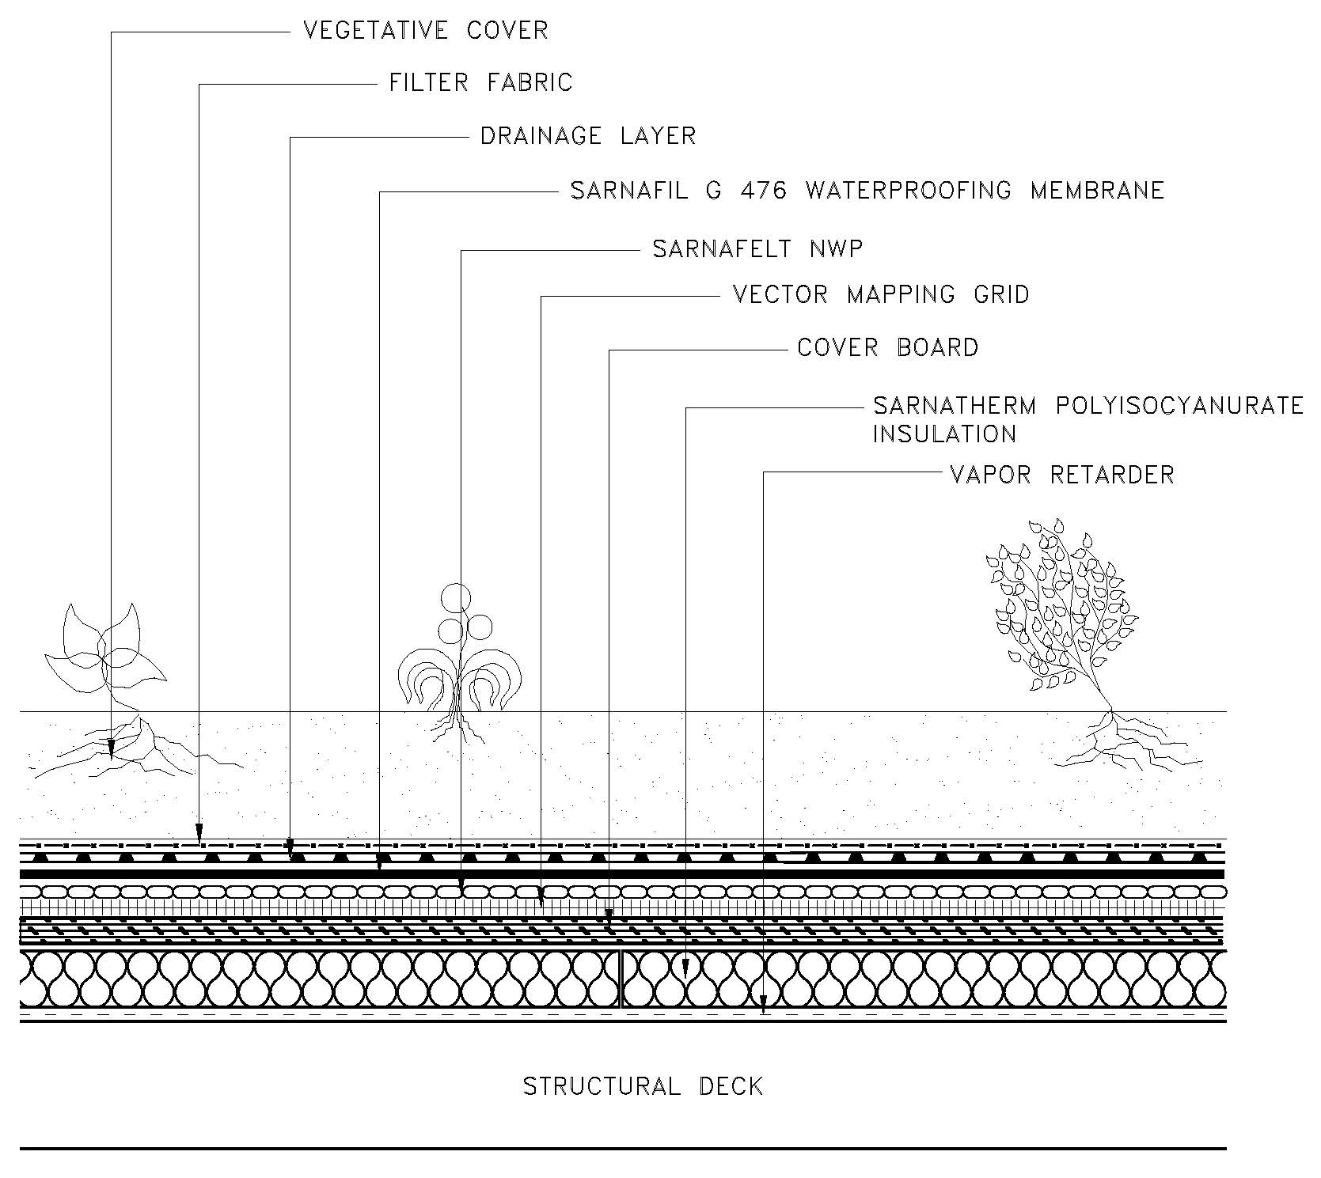

The Loose-Laid System Assembly 2 design includes the following:

- Vapor Retarder (if specified).
- Sarnatherm Polyisocyanurate Insulation.
- Cover Board.
- Vector Mapping Grid (VMG) for Electronic Leak Detection Testing.
- Sarnafelt NWP Separation Layer (optional).
- Sarnafil G476 Waterproofing Membrane.
- Drainage Layer.
- Filter Fabric (optional).

ASSEMBLY 3

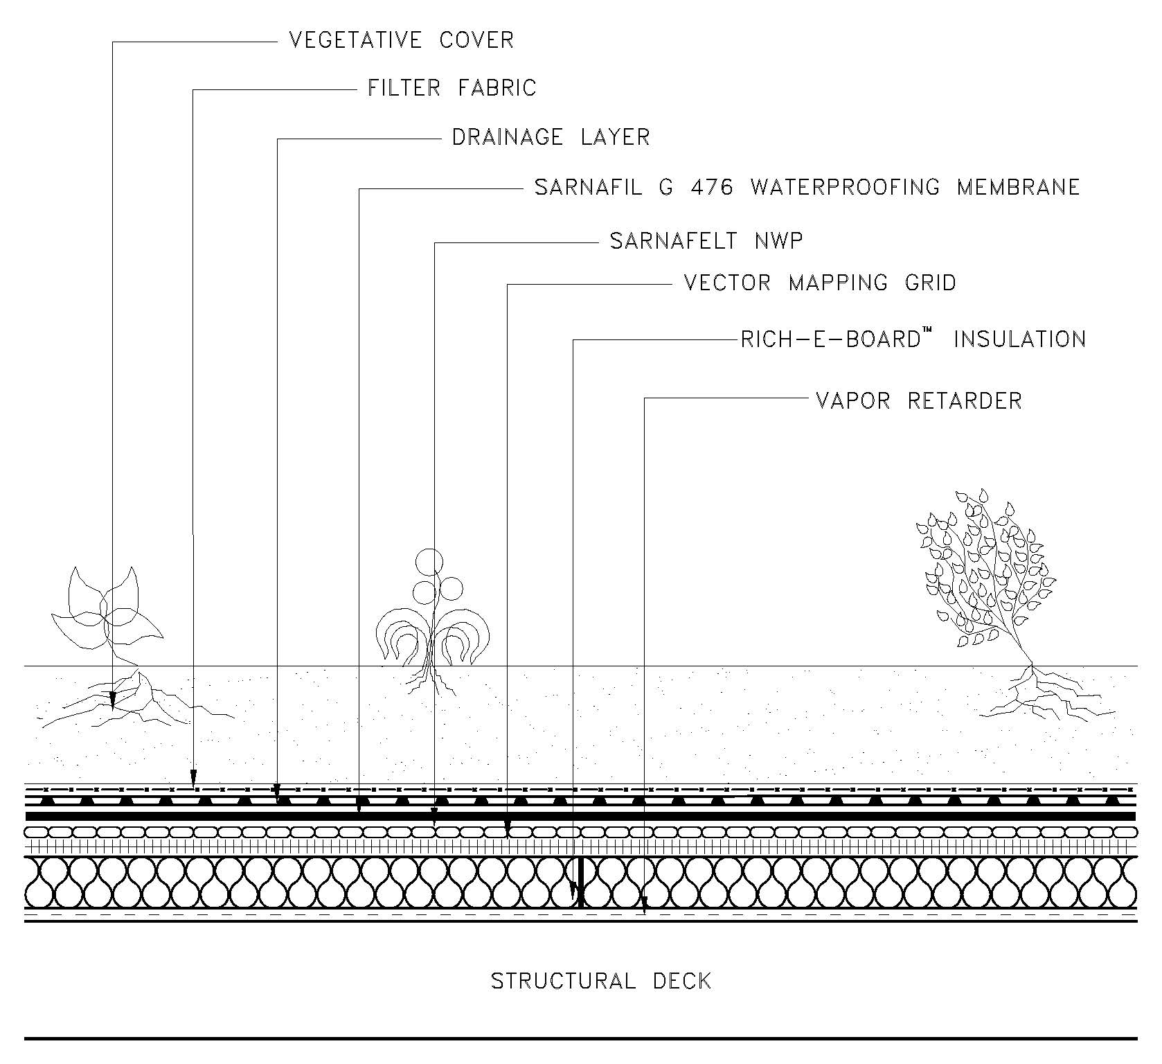

The Loose-Laid System Assembly 2 design includes the following:

- Vapor Retarder (if specified).
- Rich-E-Board™ Insulation.
- Vector Mapping Grid (VMG) for Electronic Leak Detection Testing.
- Sarnafelt NWP Separation Layer (optional).
- Sarnafil G476 Waterproofing Membrane.
- Drainage Layer.
- Filter Fabric (optional).

REGIONAL OFFICES

NEW ENGLAND REGION  225 Dan Road  Canton, MA 02021  Phone: (781) 821-0865  Fax: (781) 821-9205  EASTERN REGION  One Park Way 3rd Floor  Upper Saddle River, NJ 07458  Phone: (201) 327-0479  Fax: (201) 327-4069  SOUTHERN REGION  3483 Satellite Boulevard  Duluth, GA 30096  Phone: (770) 495-0025  Fax: (770) 495-0027  MIDWEST REGION  200 W. 22nd St., Suite 216  Lombard, IL 60148  Phone: (800) 532-5123  Fax: (630) 620-9646 | SOUTHWEST REGION  3000 FM 3538  Sealy, TX 77474  Phone: (979) 472-2015  Fax: (979) 627-7952  MOUNTAIN REGION  2881 South 900 West  Salt Lake City, UT 84119  Phone: (801) 575-8648  Fax: (801) 355-4407  WESTERN REGION NORTH  2375 Rodolfo Court  Sparks, NV 89436  Phone: (775) 626-7701  Fax: (775) 626-7703  WESTERN REGION SOUTH  15616 Euclid Avenue  Chino, CA 91710  Phone: (714) 898-9355  Fax: (714) 898-9357
WEB ADDRESS:  www.sikacorp.com | EMAIL ADDRESS:  webmaster.sarnafil@us.sika.com
SIKA CANADA - ROOFING
6915 Davand Drive
Mississauga, ON L5T 1L5
Phone: (905) 795-3177
Fax: (905) 795-3192
www.sika.ca

SECTION 07 54 19
THERMOPLASTIC MEMBRANE WATERPROOFING
LOOSE-LAID SYSTEM

TO DISPLAY OR HIDE SPECIFIER NOTES
MS Word (2007 and later):
1. Select the OFFICE logo or FILE in the upper left corner.
2. Select OPTIONS.
3. Select DISPLAY on the left menu.
4. Select HIDDEN TEXT under “Always Show These”.

GENERAL CONDITIONS

DESCRIPTION

Scope

To install a loose-laid thermoplastic membrane green roof waterproofing system with integral flashings and other components.

The work includes but is not necessarily limited to the following:

Substrate Preparation

Thermal Barrier (If Specified)

Vapor Retarder (If Specified)

Insulation

Cover Board (If Required)

Vector Mapping Grid and Connections

Geotextile Separation Layer (If Required)

Waterproofing Membrane

Membrane Flashings

Metal Flashings

Drainage Composite (If Specified)

Sealants and Adhesives

Monitoring the Installation of Vegetative Cover

Pavers (If Specified)

Related Work Under Other Sections

QUALITY ASSURANCE

This waterproofing system shall be applied only by a waterproofing Applicator authorized by Sika Corporation prior to bid. All work shall be completed by Sika trained personnel.

Installation of all waterproofing system components up to and including the waterproofing membrane shall be the responsibility of the waterproofing applicator to ensure undivided responsibility.

Obtain primary waterproofing materials, membrane and flashings, from a single manufacturer with not less than 20 years of successful experience in waterproofing application. Provide other system components only as approved by manufacturer of primary materials.

Pre-construction conference to be held with the owner, architect, Applicator’s field superintendent, waterproofing foreman, Sika representative, and other involved trades to discuss waterproofing practices applicable to this project.

There shall be no deviation made from the contract specification or the approved shop drawings without prior written approval by the owner or the owner’s representative, and/or design professional, and Sika.

The Applicator shall follow Sika’s most current quality assurance procedures.

Cross-section seam samples shall be taken by the applicator a minimum of two times a day (AM/PM) through completed seams and evaluated immediately. The samples must be dated and saved for evaluation by a Sika Technical Representative. Each test cut shall be patched by the Applicator.

Membrane Testing for Water Tightness

Water Testing of Drains

The Applicator shall water test drains according to Sika’s most current Quality Assurance Procedures. See Section 3.15.

SEE TECHNICAL BULLETIN #03-12 FOR IMPORTANT INFORMATION CONCERNING THE USE OF ELECTRONIC LEAK DETECTION FOR LOCATING LEAKS THROUGH OVERBURDEN.

Electric Field Vector Mapping® (EFVM®)

Electronic Leak Detection Testing (System, or Single-Source Warranty) – The waterproofing applicator shall arrange for testing through Sika. See Section 3.15.

Electronic Leak Detection Testing (Membrane Warranty) – The waterproofing applicator shall arrange for testing by a qualified testing agency. See Section 3.15.

SUBMITTALS

The Applicator shall submit to the owner’s representative and/or design professional the following:

A letter from Sika certifying that the Applicator is an approved waterproofing applicator in good standing.

Specimen copy of Sika’s warranty.

Specimen copy of Applicator’s warranty.

PRODUCT DELIVERY, STORAGE AND HANDLING

All products delivered to the job site shall be in the original unopened containers or wrappings.

Handle all materials to prevent damage. All materials shall be placed on pallets and fully protected from moisture with canvas tarpaulins.

Membrane rolls shall be stored lying down on pallets and fully protected from moisture with canvas tarpaulins.

Bonding adhesives shall be stored at temperatures above 40 degree F (5 degree C).

All flammable materials shall be stored in a cool dry area away from sparks and open flames. Follow precautions outlined on container or supplied by the material manufacturer/supplier.

Any materials which the owner’s representative and/or Sika determine to be damaged are to be removed from the job site and replaced at no cost to the owner.

JOB CONDITIONS

Proceed with waterproofing membrane installation only after substrate preparation is complete. Owner’s representative and/or design professional and waterproofing Applicator must accept substrate before proceeding with membrane installation.

Substrate must be clean and smooth. With the exception of areas to receive grid strips, damp concrete is acceptable, however no standing or visible water is allowed. Do not work in rain or snow or adverse weather conditions. Severe temperatures, moisture and humidity may affect the installation of products during construction. Comply with applicable installation requirements for all components.

All work shall be scheduled and executed without exposing completed waterproofing system and interior building areas to the affects of inclement weather. The building and its contents shall be protected against all risks.

The structure must be designed to support the system, including the vegetative cover. The adequacy of the structural support must be verified in writing by the owner, the owner’s design professional, architect, or engineer. The Applicator shall take precautions that storage and/or application of materials and/or equipment does not overload the deck or building structure.

All new and temporary construction, including equipment and accessories, shall be secured in such a manner, at all times, as to preclude wind blow-off or damage.

Liquid materials such as solvents and adhesives shall be stored and used away from open flames, sparks and excessive heat.

The Applicator should take necessary precautions when using adhesives or surface conditioner around air in-takes. The smell of the adhesive, primer, or surface conditioner could be a disturbance to the building owner and occupants. It is the Applicator’s responsibility to notify the owner and take the proper precautions.

The Applicator shall verify that all drain lines are connected and un-blocked before starting work. Report any blockages or non-connected drains to the owner’s representative and/or design professional in writing.

The Applicator is cautioned that Sarnafil membranes are incompatible with asphalt, coal-tar, polystyrene, oil-based and plastic-based cements, creosote, penta-based materials, grease, fats, oils, and solvents. Such materials shall not come in contact with the waterproofing membrane at any time. If such contact occurs, the material shall be cut-out, discarded and patched.

Arrange work sequence to avoid use of newly installed waterproofing for storage, walking surface, and equipment movement. Where such access is absolutely required, the Applicator shall provide all necessary temporary protection and barriers to segregate the work area and to prevent damage to adjacent areas. Adequate protection of the membrane shall be provided for all waterproofing areas which receive traffic during construction. Any damage which occurs to the waterproofing membrane and/or system is to be brought to the attention of the owner’s representative and/or design professional and Sika. All damage is to be repaired according to Sika’s recommendations. The party responsible for damage shall bear the cost of repairs.

All waterproofing materials, insulation, flashings and metal work removed for construction shall be immediately taken off the site to a legal dumping area authorized to receive such materials.

If any unusual or concealed condition is discovered, stop work and notify the owner’s representative and/or design professional and Sika immediately, in writing.

Site cleanup, including both interior and exterior building areas in any way affected by the construction, shall be complete and to the owner’s satisfaction. All landscaped areas affected by waterproofing activities shall be raked clean and seeded, if required. All paved areas shall be swept clean. All areas stained, dirtied, and discolored or otherwise damaged due to waterproofing activities shall be cleaned, restored, and replaced as required.

SEQUENCING OF THE WORK

Do not proceed with installation of vegetative cover over the completed sections of the waterproofing without the acceptance of the owner’s representative, design professional, general contractor, and Sika (when a Standard, System, or Single-Source warranty is specified). A copy of the Final Inspection for Warranty is considered acceptance from Sika.

Protect the membrane and coordinate with other trades to avoid traffic over completed membrane surfaces.

BIDDING REQUIREMENTS

Pre-Bid Meeting

A pre-bid meeting shall be held with the Owner's Representative and involved trades to discuss all aspects of the project. The Applicator's field representative or roofing foreman for the work shall be in attendance. Procedures to avoid rooftop damage by other trades shall be determined.

Site Visit

Bidders shall visit the site and carefully examine the areas in question as to conditions that may affect proper execution of the work. All dimensions and quantities shall be determined or verified by the contractor. No claims for extra costs will be allowed because of lack of full knowledge of the existing conditions unless agreed to in advance with the Owner or Owner's Representative.

WARRANTIES

General

A Sika Representative’s presence on a project regardless of reason, length, or frequency, does not imply that any additional coverage beyond that stated in the warranty is in effect.

Applicator’s Warranty

The Applicator shall supply the owner with a minimum two-year workmanship warranty. The warranty obligation shall run directly to the owner with a copy to Sika.

Sika Warranty

Membrane Warranty (5, 10, 15, or 20 Years)

The Applicator shall provide a Sika membrane warranty to the building owner at the successful completion of the project. The warranty shall cover defective waterproofing membrane.

System Warranty (5, 10, 15, or 20 Years)

The Applicator shall provide a Sika System warranty to the building owner. Upon successful completion of the work to Sika’s satisfaction and receipt of final payment, the Sika System Warranty shall be issued.

Single-Source Warranty – Extensive Green Roofs (5, 10, 15, or 20 Years)

The Applicator shall provide a Sika Single-Source warranty to the building owner at the successful completion of the project. The waterproofing membrane manufacturer shall warrant to the building owner the vegetative cover, and the repair of leaks in the waterproofing membrane resulting from defects in the membrane or workmanship.

PRODUCTS

General

Consult Product Data Sheet for additional information on Sika products.

WATERPROOFING MEMBRANE

The manufacturer of the thermoplastic waterproofing membrane system shall have a track record of producing and marketing a reinforced PVC sheet system for waterproofing applications for at least 20 years and guarantee that the membrane thickness meets or exceeds [the specified thickness] when tested according to ASTM D751. Subject to this and other technical requirements, provide products of the following:

Sarnafil G476-15, 60 mil (1.5 mm), thermoplastic polyvinyl chloride (PVC) membrane with non-woven fiberglass reinforcement.

Sarnafil G476-20, 80 mil (2.0 mm), thermoplastic polyvinyl chloride (PVC) membrane with non-woven fiberglass reinforcement.

Typical Physical Properties ⁽¹⁾

Sarnafil G 476 Waterproofing Membrane

* Results may differ based upon statistical variations depending upon mixing methods and equipment, temperature, application methods, test methods, actual site conditions, and curing conditions.
Properties | ASTM  Test Method | Typical Results
Overall Thickness, mil | D751 | 60 | 80
Reinforcing Material | -- | Fiberglass | Fiberglass
Weight, lb/ft² (kg/m²) | -- | 0.39 (1.93) | 0.52 (2.6)
Breaking Strength, lbf/in (N) | D751 | 92 (409) | 121 (538)
Elongation at Break, % M.D.1 & C.M.D.¹ | D751 | 255 & 240 | 296 & 290
Seam Strength, % of original² | D751 | 90 | 90
Retention of Properties After Heat Aging | D3045 | -- | --
Tensile Strength, % of original | D751 | 95 | 95
Elongation, % of original | D751 | 95 | 95
Tearing Resistance, lbf (N) | D1004 | 17 (76) | 21 (93)
Low Temperature Bend, -40°F (-40°C) | D2136 | Pass | Pass
Linear Dimensional Change, % | D1204 | 0.01 | 0.01
Weight Change After Immersion in Water, % | D570 | 2.5 | 2.1
Static Puncture Resistance | D5602 | Pass | Pass
Dynamic Puncture Resistance, ft-lbf (J) | D5635 | Pass | Pass

¹ M.D. = Machine Direction, C.M.D. = Cross Machine Direction
² Failure occurs through membrane rupture not seam failure.

SYSTEM FLASHING PRODUCTS AND ACCESSORIES

Flashing

Non-exposed flashings

Sarnafil G476-15, 60 mil (1.5 mm), thermoplastic flashing membrane with fiberglass reinforcement.

Sarnafil G476-20, 80 mil (2.0 mm), thermoplastic flashing membrane with fiberglass reinforcement.

Exposed flashings

Sarnafil G410-15, 60 mil (1.5 mm), thermoplastic flashing membrane with fiberglass reinforcement.

Sarnafil G410-20, 80 mil (2.0 mm), thermoplastic flashing membrane with fiberglass reinforcement.

G459-15, 60 mil (1.5 mm), thermoplastic, asphalt resistant, grid and flashing membrane with fiberglass reinforcement.

Adhesives

Sarnacol 2170 or Sarnacol 2170 VC

Solvent-based adhesive for membrane flashings.

Sarnacol 2121

Water-based adhesive for membrane flashings.

Sikaflex-11FC

Membrane adhesive for certain flashing details and pitch pocket filler.

Attachment Components

Fastener-CD10

A nail-in, corrosion-resistant fastener used with Sarnabar-Stainless Steel to attach Sarnafil membrane to structural concrete roof decks.

Sarnafastener #14

A #14 corrosion-resistant fastener used with Sarnabar-Stainless Steel to attach Sarnafil membrane to structural concrete or wood roof decks.

Sarnafastener #15 XP

A #15, heavy-duty, corrosion-resistant fastener used with Sarnabar-Stainless Steel to attach Sarnafil membrane to steel roof decks.

Sarnabar-Stainless Steel

Heavy-duty, 14 gauge, roll-formed stainless steel bar used to attach membrane to decks.

Sarnastop

An extruded aluminum, flat low profile bar used to terminate flashing membrane.

Masonry Anchor

A drive-pin expansion type fastener with zinc sheaths and stainless steel pins for attachment of Sarnabar and Sarnastop to concrete, masonry, and brick.

Accessories

Sarnaclad-Stainless Steel

A PVC-coated, heat weldable sheet metal capable of being formed into a variety of shapes and profiles. Sarnaclad is a stainless steel sheet metal with an unsupported Sarnafil membrane laminated on one side for buried or concealed flashing conditions.

Sarnaclad

A PVC-coated, heat-weldable sheet metal capable of being formed into a variety of shapes and profiles. Sarnaclad is a 25 gauge, G90 galvanized metal sheet with a 20 mil (0.5 mm) unsupported Sarnafil membrane laminated on one side for above grade flashing locations.

Aluminum Tape

A pressure-sensitive aluminum tape used as a separation layer between small areas of asphalt contamination and as a bond-breaker under the coverstrip at Sarnaclad-SS joints.

Sarnamatic

220 volt, self-propelled, hot-air welding machine used to seal long lengths of Sarnafil membrane seams.

Sarnacorner-Inside/Outside

Prefabricated inside and outside flashing corners made of PVC membrane that are heat-welded to membrane or Sarnaclad base flashings.

Sikaflex Primer 449

A solvent based primer used to prime the back of G459 grid strip membrane to improve adhesion to Sikaflex-11FC grid adhesive.

Sikaflex®-1a

Sealant used at flashing terminations and pitch pocket filler.

Multi-Purpose Tape

A high performance sealant tape used with metal flashings as a preventive measure against air and wind blown moisture entry.

Sarnacircle

Circular 48 mil (1.2 mm) G410 membrane patch welded over T-joints formed by overlapping membranes greater than 60 mil (1.5 mm) in thickness.

Sarnacord-PVC

A 5/32 inch (4 mm) diameter, red-colored, flexible thermoplastic extrusion that is welded to the top surface of the Sarnafil membrane against the outside edge of Sarnabar-Stainless Steel, used to hold the membrane in position.

VAPOR RETARDERS AND ACCESSORIES

[NOTE TO SPECIFIERS: IF SPECIFIED, SELECT ONLY ONE VAPOR RETARDER.]

Vapor Retarder PE 10

A 10 mil (0.25 mm) polyethylene vapor retarder/air retarder.

Vapor Retarder A 31

A 32 mil (0.8 mm) self-adhesive vapor retarder that can also serve as temporary roof protection.

Vapor Retarder SA 106

A 106 mil (2.7 mm) self-adhesive vapor retarder that can also serve as a temporary roof protection.

Vapor Retarder TA 138

A 138 mil (3.5 mm) torch applied SBS modified bitumen polyester reinforced vapor retarder that can also serve as temporary roof protection.

Ply Sheet HA 87

A 87 mil (2.2 mm) hot applied SBS polymer modified bitumen fiberglass reinforced ply sheet that can be used as a vapor retarder.

Ply Sheet TA 87
A 87 mil (2.2 mm) thick torch applied SBS modified bitumen fiberglass reinforced ply sheet that can be used as a vapor retarder.

Accessories

      - Vapor Retarder Primer SB

Solvent-based primer used to prime wood, concrete, lightweight concrete, gypsum boards and decks, and DensDeck® boards prior to the application of Sika’s self-adhered vapor retarders.

      - Vapor Retarder Primer VC

Primer used to prime wood, concrete, lightweight concrete, gypsum boards and decks, and DensDeck® boards prior to the application of Sika’s self-adhered vapor retarders.

      - Vapor Retarder Primer WB

Water-based primer used to prime wood, concrete, lightweight concrete, gypsum decks, and approved gypsum boards prior to the application of Sika’s self-adhered vapor retarders. For use in areas where solvent-based primers are not advised and/or are not permitted.

      - Vapor Retarder Primer TA

Primer used on concrete decks prior to applying Sika’s torch-applied vapor retarders and prior to application of hot asphalt for Sika’s ply sheets.

      - Mastic

Fiber reinforced SS modified bitumen mastic to detail and seal around penetrations and flashings.

INSULATION/THERMAL BARRIER/COVER BOARD

Sarnatherm XPS

Extruded polystyrene closed-cell foam insulation. Thicknesses and compressive strength as noted on Project Drawings.

Sarnatherm Polyisocyanurate

A rigid polyisocyanurate foam insulation with black mat facers. Thicknesses and compressive strength as noted on Project Drawings.

Rich-E-Board™

A high density composite vacuum insulated panel. Thickness and R-value noted on project drawings.

DensDeck® Roof Board

A siliconized gypsum, fire-tested roof board with glass-mat facer used as a thermal barrier underlayment in certain roof constructions. Thicknesses as noted on Project Drawings.

[NOTE TO SPECIFIERS: SELECT COVER BOARD OR ROOF BOARD E. OR F. IF B. OR C. ABOVE IS SELECTED.]

DensDeck® Cover Board

A 1/4 inch (6 mm) thick fire-tested, gypsum cover board with glass-mat facers.

Sarnatherm Roof Board

A lightweight, high density, polyisocyanurate roof board with coated glass facers.

Vector Mapping Grid and Connections

Vector Mapping Grid (VMG)

A specially selected 2” x 2” (50 mm x 50 mm) 304 stainless steel grid that serves as a conductive medium below the membrane used in conjunction with EFVM.

EFVM Connection Kit

Connects the Vector Mapping Grid to the leak detection equipment. It consists of two (2) 0.45 mm, 6” x 6” SS 304 stainless steel EFVM connection plates, insulated, exterior graded 16 gauge low voltage wire, 5’-6” in length. The EFVM Connection Kit is utilized to electrically energize the Vector Mapping Grid during the EFVM test.

SEPARATION LAYER (If Specified)

Sarnafelt NWP

A non-asphaltic, non-woven polypropylene felt separation layer used between Vector Mapping Grid (VMG) and waterproofing membrane, or used above the membrane as an additional protective layer as required. Sarnafelt NWP is required between the Vector Mapping Grid (VMG) and the membrane when the VMG is installed directly over XPS insulation. The membrane must not come in direct contact with polystyrene insulation.

DRAINAGE COMPOSITE

Drainage Composite 3811R

A 100% recycled polypropylene drainage core of fused, entangled filaments with a geocomposite fabric bonded to each side.

Geonet B

A polymeric drainage net with polypropylene geotextile laminated to both sides. Recommended for heavy traffic areas requiring higher compressive strength but where lower flow rates are acceptable.

PRECAST CONCRETE PAVERS AND PEDESTALS

Pavers shall be hydraulically pressed concrete units manufactured by Hanover Architectural Products or Oldcastle/Westile Inc. or Wausau Tile Inc., and supplied by Sika Corporation.

Precast Concrete Pavers and Pedestal System by Hanover Architectural Products and supplied by Sika Corporation.

Precast Concrete Pavers and Pedestal System by Oldcastle/Westile Inc. and supplied by Sika Corporation.

Precast Concrete Pavers and Pedestals System by Wausau Tile Inc. and supplied by Sika Corporation.

Concrete pavers shall comply with the following minimum requirements:

Physical Property | ASTM Test Method | Requirements
Dimensional Tolerances | C140 | As specified ±1/8 inch maximum
Compressive Strength | C140 | 8000 psi minimum
Flexural Strength | C293 | 725 psi minimum
Freeze Thaw Resistance | C67 | 25 cycles, max. 1% loss
Water Absorption | C140 | 5% or less

Precast Concrete Paver thickness shall be: ______

Precast Concrete Paver finish shall be: ______

Precast Concrete Paver color shall be: ______

Precast Concrete Paver size shall be: ______

Pedestal System shall be: ______

RELATED MATERIALS

Wood Nailer

Wood nailers shall be treated for fire and rot resistance (ACQ treated) and be #2 quality or better lumber. Creosote or asphalt-treated wood is not acceptable. Wood nailers shall conform to Factory Mutual Loss Prevention Data Sheet 1-49. All wood shall have a maximum moisture content of 19% by weight on a dry-weight basis.

Plywood

When adhering the flashing membrane directly to plywood, a minimum 1/2 inch (13 mm) CDX (C side out), smooth-surfaced exterior grade plywood with exterior grade glue shall be used. Rough-surfaced plywood or high fastener heads will require the use of Sarnafelt behind the flashing membrane. Plywood shall have a maximum moisture content of 19% by weight on a dry weight basis.

Miscellaneous Fasteners and Anchors

Fasteners are to be compatible with materials in contact with fasteners. All fasteners and anchors shall have a minimum embedment of 1-1/4 inches (31.7 mm) and shall be approved for such use by the fastener manufacturer. Fasteners for attachment of metal to wood blocking shall be annular ring nails. Fasteners for attachment of metal to masonry shall be all-metal expansion type fasteners. All fasteners shall meet Factory Mutual Standard 4470 for corrosion resistance.

EXECUTION

EXAMINATION

Examine all surfaces scheduled to receive waterproofing membrane and flashing for roughness, contaminants, unsound structural substrates or other conditions that may impair the waterproofing application. Notify the owner and copy Sika in writing of any such conditions. Do not commence work until all defects are remedied.

Applicator shall be responsible for acceptance or provision of proper substrate to receive new waterproofing materials.

Applicator shall verify that the work done under related sections meets the following conditions:

Roof drains and/or scuppers have been reconditioned and/or replaced and installed properly.

Roof curbs, nailers, equipment supports, vents and other roof penetrations are properly secured and prepared to receive new waterproofing materials.

All surfaces are smooth and free of dirt, debris and incompatible materials.

SUBSTRATE PREPARATION

New Construction

Steel Deck:

The structural deck shall be minimum 24 gauge, grade D and shall conform and be installed according to the current local code requirements.

Wood Deck:

The structural deck shall be minimum 1-1/2 inch (38 mm) thick lumber or 15/32 inch (12 mm) thick plywood. Deck shall be installed according to the current local code requirements.

Poured Structural Concrete Deck:

The structural deck shall be installed and cured in accordance with industry standards. The surface shall have a smooth and level finish and shall be free of excess moisture and loose debris. Sharp ridges or other projections above the surface shall be removed before installation of roofing assembly.

Precast/Prestressed Concrete Panel Deck:

The structural deck shall be installed in accordance with the concrete panel manufacturer's requirements and industry practice. The surface shall have a smooth and level finish and shall be free of excess moisture and loose debris. All joints between precast units shall be grouted with SikaGrout® 212 non-shrink, cementitious grout. Any differentials in height between precast units shall be feathered for a smooth transition. Sharp ridges or other projections above the surface shall be removed before installation of roofing assembly.

Removal of Existing Waterproofing

General Criteria

All existing overburden, waterproofing, base flashing, deteriorated wood blocking or deteriorated metal flashings shall be removed. Remove only that amount of waterproofing and flashing that can be made weathertight with new materials during a one-day period or before the onset of inclement weather.

Residual material of most products, including those that are asphalt based, may remain with the exception of coal tar. All coal tar pitch residue must be completely removed.

Steel Deck:

All rusted or deteriorated decking shall be brought to the attention of the Owner's Representative to determine method of treatment or replacement. Surface-only rusted metal shall be sanded and treated with rust-inhibiting paint. Sections that have rusted deeper than the surface or are not structurally sound shall be removed and replaced with matching deck type.

Wood Deck:

All rotted or deteriorated wood shall be removed and replaced.

Poured Structural Concrete Deck:

The surface shall have a smooth and level finish and shall be free of excess moisture and loose debris. Sharp ridges or other projections above the surface shall be removed before installation of roof assembly.

Precast/Prestressed Concrete Deck:

The surface shall have a smooth and level finish and shall be free of excess moisture and loose debris. All joints between precast units shall be grouted with SikaGrout® 212 non-shrink, cementitious grout. Any differentials in height between precast units shall be feathered for a smooth transition. Sharp ridges or other projections above the surface shall be removed before installation of roof assembly.

WOOD NAILER INSTALLATION

Install continuous wood nailers at the perimeter of the entire area and around projections and penetrations as shown on the Project Drawings. Thickness shall be as required to match substrate and/or insulation height to allow a smooth transition.

Nailers shall be anchored to resist a minimum force of 300 pounds per lineal foot (4,500 Newtons/lineal meter) in any direction. Individual nailer lengths shall not be less than 3 feet (0.9 meter) long. Nailer fastener spacing shall be at 12 inches (0.3 m) on center or 16 inches (0.4 m) on center if necessary to match the structural framing. Fasteners shall be staggered 1/3 the nailer width and installed within 6 inches (0.15 m) of each end. Two fasteners shall be installed at ends of nailer lengths. Nailer attachment shall also meet the requirements of the current Factory Mutual Loss Prevention Data Sheet 1-49.

Stainless steel, corrosion resistant, fasteners are required when mechanically attaching any Sika product to wood nailers and wood products treated with ACQ (Alkaline Copper Quaternary). When ACQ treated wood is used on steel roof decks or with metal edge detailing, a separation layer must be placed between the metal and ACQ treated wood.

THERMAL BARRIER INSTALLATION (If Specified)

Thermal barrier boards shall be laid over the substrate in parallel courses with end joints staggered and tightly butted.

Thermal barrier boards shall be neatly cut to fit around penetrations and projections.

When installed directly on fluted steel decks, the edge joints of the thermal barrier boards are to be parallel to and over deck ribs with end joints staggered.

Do not install more thermal barrier board than can be covered with waterproofing membrane by the end of the day or the onset of inclement weather.

Consult Product Data Sheet for additional installation instructions and information.

VAPOR RETARDER INSTALLATION

General

Prime substrate as required by Sika according to Sika’s printed instructions. Allow primer to completely dry.

Vapor Retarder PE 10

Vapor Retarder PE 10 is loose-laid over suitable substrate.

Overlap all edges 4 inches (100 mm) and seal with Sika’s Multi-Purpose Tape.

Extend Vapor Retarder PE 10 to perimeter and deck penetrations and seal to provide continuity of the building's air/vapor envelope.

Seal Vapor Retarder PE 10 on the vertical surface at roof penetrations.

Vapor Retarder SA 31

Install Vapor Retarder SA 31 over a clean and dry substrate. Install in temperatures 14 degree F (-10 degree C) and above. On metal decks use a metal plate (6 in x 42 in. - 15 x 106 cm) to support the membrane end lap between metal flutes ensuring a complete end lap seal.

Vapor Retarder SA 106

      - Install Vapor Retarder SA 106 over a clean and dry substrate. On steel decks install a 6 in x 42 in (15.2 cm x 1.1 m) metal plate under the end lap to support the membrane between the steel flutes. Stagger the end laps by at least 12 in (30.5 cm). Roll Vapor Retarder SA 106 with a 100 lb (45 kg) steel roller to ensure full contact with the substrate. Align successive sheets with 3 in (7.6 cm) side laps and 6 in (15.2 cm) end laps. Hot air weld the end laps.

    - Vapor Retarder TA 138

Concrete surfaces must be dry before installation. Unroll Vapor Retarder TA 138 and allow sheet to relax prior to torching. Side laps must be a minimum of 3 in (7.6 cm). End laps should be a minimum of 6 in (15.2 cm). Staggered adjacent end laps a minimum of 12 in (30.5 cm). Ensure that all laps are firmly and smoothly adhered without wrinkles, voids or fishmouths.

    - Ply Sheet HA 87

Adhere Ply Sheet HA 87 to the substrate with Type III or Type IV asphalt according to the asphalt manufacturer’s instructions and industry standards. Apply a full mopping of Type III or Type IV asphalt in accordance with manufacturer’s instruction at a minimum rate of 25 lbs per 100 square feet (1.2 kg/m²). Install Ply Sheet HA 87 so that there are no significant and avoidable air spaces between the ply sheet and the substrate. Overlap side laps 3 in (76 mm) and end laps 6 in (15.2 cm).

    - Ply Sheet TA 87

Concrete surfaces must be dry before installation. Unroll Ply Sheet TA 87 and allow the sheet to relax prior to torching. Side laps must be a minimum of 3 in (7.6 cm). End laps should be a minimum of 6 in (15.2 cm). Stagger adjacent end laps a minimum of 12 in (30.5 cm). Ensure that all laps are firmly and smoothly adhered without wrinkles, voids or fishmouths.

INSULATION INSTALLATION

[NOTE TO SPECIFIERS: SELECT SECTION A. OR B. BASED ON INSULATION SELECTED IN 2.03.]

Extruded Polystyrene or Polyisocyanurate Insulation Boards

For Factory Mutual insured buildings polystyrene insulation cannot be applied direct to steel deck.

Insulation shall be installed according to manufacturer’s instructions.

If tapered insulation is specified, install in accordance with approved tapered layout.

Insulation shall be laid over the substrate in parallel courses with end joints staggered and tightly butted.

Insulation shall be neatly cut to fit around penetrations and projections.

Do not install more insulation board than can be covered with membrane by the end of the day or the onset of inclement weather.

Use at least 2 layers of insulation when the total insulation thickness exceeds 2-1/2 inches (64 mm). Stagger joints at least 12 inches (0.3 m) between layers.

Insulation shall be butted together having no gaps greater than ¼ inch (6 mm).

    - Rich-E-Board Vacuum Insulated Composite Panel

      - Insulation shall be installed according to manufacturer’s instructions.
      - Insulation shall be loose-laid over the substrate in parallel courses with end joints staggered and tightly butted.
      - Do not cut, puncture, or install fasteners through the vacuum insulated composite panel. Use polyisocyanurate insulation of equivalent thickness to fill areas not covered with vacuum insulated composite panel.
      - Use polyisocyanurate tapered edge strips when slope is required such as in drain sumps.
      - Do not install more vacuum insulated composite panel than be covered with membrane by the end of the day or the onset of inclement weather.
      - Insulation shall be butted together having no gaps greater than ¼ inch (6 mm).

COVER BOARD INSTALLATION

[NOTE TO SPECIFIERS: DELETE SECTION IF 3.06 B. IS SELECTED]

Cover board shall be laid over insulation with all joints offset from insulation boards.

Install in parallel courses with end joints staggered and tightly butted.

Cover board shall be neatly cut to fit around penetrations and projections.

Do not install more cover board than can be covered with membrane by the end of the day or the onset of inclement weather.

VECTOR MAPPING GRID AND CONNECTIONS INSTALLATION

Lay the Vector Mapping Grid over the cover board or XPS insulation or vacuum insulated panel. Follow Sika’s Vector Mapping Grid (VMG) installation procedures.

SEPARATION LAYER INSTALLATION (If Specified)

Install separation layer over Vector Mapping Grid, lapping all edges a minimum of 4 inches (10.2 cm). Spot adhere to hold in place, if necessary.

Install only as much separation layer as can be made weathertight at the end of each work period.

Separation layer is installed above the membrane as additional protection as specified and according to the detail drawings lapping all edges a minimum of 4 inches (10.2 cm).

Cut separation layer with scissors. Do not use hot air welding equipment to cut the separation layer.

THERMOPLASTIC WATERPROOFING MEMBRANE INSTALLATION

Comply with Sika’s most current installation instructions, specific recommendations, and approved shop drawings for this project.

Workmen and all others that walk on waterproofing shall wear clean, soft-soled shoes so as not to damage materials. Heed all manufacturer’s cautions and warnings in regard to product use. Membrane is slippery when wet or covered with frost, snow and ice. Take proper precautions. Lay out work to minimize traffic over installed areas.

Unroll and position the waterproofing membrane over the substrate. Remove all shipping tape from the membrane.

HOT-AIR WELDING OF LAP AREAS

- General

All surfaces to be welded shall be clean and dry. No contaminants shall be present within lap areas.

Welding equipment shall be provided by or approved by Sika. All mechanics intending to use the equipment shall be trained and qualified and shall have successfully completed a course of instruction provided by Sika’s representative prior to welding.

Adjacent sheets shall be welded in accordance with Sika’s instructions. All side and end lap joints shall be hot air welded. Lap area shall be a minimum of 3 inch (76.2 mm) wide when machine welding, and a minimum of 4 inch (10.2 cm) wide when hand welding. Overlaps shall be with the flow of water where possible.

Install Sarnabar-Stainless Steel fastened 12 inches (30 cm) on center with acceptable fasteners into the structural deck, at the base of parapets, walls, and curbs according to Sika’s recommended details. Hot-air weld PVC cord to the waterproofing membrane on the penetration side of the Sarnabar-Stainless Steel. Weld a 4 in. (10.2 cm) wide membrane protection strip over bar ends and intersections.

- Machine Welding

Machine welded seams are achieved by the use of automatic welding equipment. When using this equipment, Sika's instructions must be followed and local codes for electric supply, grounding and over current protection observed. Dedicated circuit house power or a dedicated portable generator (30 A, 220 V, and recommended min. 7,500 Watts) is required. No other equipment shall be operated off the generator.

- T-Joints (three-way overlaps)

The second layer (middle layer) of membrane of all T-Joints formed with membrane greater than 60-mils in thickness must be shaved down to create a smooth transition for the top layer of membrane prior to hot-air welding. A 4 inch (10.2 cm) round or square (with rounded corners) patch of max. 60 mil thick G476, G410, or G459 membrane must be hot-air welded over the center of the T-Joint intersection. The edges of the membrane forming the T-Joint must be shaved to provide a smooth transition for the patch.

- Quality Control of Welded Seams

All completed welded seams shall be checked by the waterproofing Applicator after cooling for continuity using a rounded screwdriver or other suitable blunt object. On-site evaluation of welded seams shall be made daily by the Applicator. Cross-section samples shall be taken a minimum of two times a day (AM/PM) through completed seams and evaluated immediately. The samples must be dated and saved for evaluation by a Sika Technical Representative. Each test cut shall be patched by the Applicator.

MEMBRANE FLASHINGS

- All flashings shall be installed concurrently with the waterproofing membrane according to Sika approved details as the job progresses. Flashings shall be adhered to compatible, dry, smooth, and solvent-resistant surfaces. All masonry joints shall be struck flush. Rough or incompatible surfaces may be covered with minimum 1/2 inch (13 mm) CDX plywood.

- When adhering to vertical surfaces greater than 30 inches (76.2 cm) in height, provide intermediate fastening of the flashing membrane according to Sika requirements.

- Complete the entire waterproofing assembly and flashing in a single working day; avoid exposure of any components to rain, snow, or dew. If rain threatens during the day, or in an emergency, protect the unfinished exposed waterproofing and flashing components.

- All flashing membranes shall be mechanically fastened along the top edge according to approved Sika details. Acceptable fasteners shall be used to secure flashings to substrate. Seal top of termination with an acceptable sealant.

- All flashings shall extend a minimum of 8 inches (20.3 cm) above the overburden unless previously accepted by the owner’s representative and/or design professional and Sika, in writing.

- All interior and exterior corners and miters shall be cut and hot-air welded into place. Complete inside and outside corner flashing details with prefabricated corner patches (Sarnacorners).

- No bituminous elements shall be in contact with the waterproofing membrane, unless asphalt resistant membrane is used. Flashing substrates contaminated with coal-tar shall be completely cleaned, or overlaid with minimum 1/2 inch (13 mm) thick CDX plywood or minimum 24 gauge stainless steel sheet metal.

SARNACLAD METAL FLASHINGS

- Complete all metal work in conjunction with waterproofing and flashings so that a watertight condition exists daily.

- Metal shall be installed to provide adequate resistance to bending and allow for normal thermal expansion and contraction.

- Metal joints shall be watertight.

- Metal flashings shall have a 4 inch (10.2 cm) minimum nailing flange and shall be fastened into solid wood blocking 4 inches (10.2 cm) on center staggered or into concrete with acceptable concrete anchors 6 inches (15.2 cm) on center staggered. Fasteners shall penetrate the wood nailer a minimum of 1-1/4 inch (31.7 mm) or into concrete a minimum of 1 inch (25.4 mm).

- Adjacent sheets of PVC coated metal shall be spaced 1/4 inch (6.3 mm) apart. The end joints of the metal shall be fastened 6 inches (15.2 cm) on center. The joints shall be covered with 2 inch (50.8 mm) wide aluminum tape. A 4 inch (10.2 cm) wide membrane flashing strip shall be hot air welded over the joint.

TEMPORARY CUT-OFF

- All flashings shall be installed concurrently with the membrane in order to maintain a watertight condition as the work progresses. Provide temporary cut-offs around exposed edges and at incomplete flashing areas from the new membrane to the structural deck or existing waterproofing. Remove the cut-offs completely before proceeding with subsequent work.

- If inclement weather occurs while a temporary cut-off is in place, the Applicator shall provide the labor necessary to monitor the situation to maintain a watertight condition.

Electronic leak detection testing and Water Testing of Drains

- The Applicator shall water test the drains for a minimum of 16 hours prior to the EFVM test. Plug the drain and flood with enough water to completely cover the clamping ring the day before the EFVM test. The Sika Technical Service Representative attending the EFVM test will inspect for leakage upon his arrival to the jobsite.

- Perform EFVM electronic leak detection testing over the completed waterproofing membrane for testing of capillary defects and/or breaches in the membrane prior to the installation of subsequent layers.

- Should leaks be discovered, the Applicator shall locate leak source(s) and make repairs. Re-test to assure watertightness. All costs associated with the repairs shall be borne by the Applicator.

INSTALLATION OF DRAINAGE COMPOSITE

- Install drainage composite directly over the waterproofing membrane. Install drainage composite immediately after Sika Sarnafil’s inspection and acceptance of the waterproofing installation.

Note: When pre-vegetated modules are specified, Drainage Composite 3811R must be used. Install with grey polyester fabric facing the pre-vegetated module and the black polypropylene fabric facing the waterproofing membrane.

- Neatly trim drainage composite to fit closely around penetrations and at the base of all drains to ensure that water will flow freely from composite into drain openings.

- All cut edges of the drainage composite shall be covered in order to protect the waterproofing membrane from damage.

- Proceed with installation of vegetative cover promptly.

PRECAST CONCRETE PAVER SYSTEM (If Specified)

Prior to installation of the waterproofing system and pavers, inspect the deck for height and location of thresholds, stairs, and other major transition areas.

Precast Pavers on Pedestals:

Install pavers according to the manufacturer’s published instructions.

Cut and fit pavers neatly at the base of walls and projections.

Shim or adjust pavers as required to provide a level surface with no more than 1/8 inch (3.2 mm) height differential.

Pavers will be power washed or cleaned to remove any laitance, dirt, or other unacceptable surface irregularities.

MONITORING THE VEGETATIVE COVER INSTALLATION

- The waterproofing Applicator shall monitor vegetative cover installation and to assure no damage is done to the waterproofing membrane.

- Alert all parties concerned of any activities that might damage or adversely affect the long-term performance of the waterproofing.

DETAILS

Refer to system specific details at http://usa.sarnafil.sika.com.

